**Deploy an application on Tomcat server by using Jenkins:**

* First create the ec2 instance and connect to that instance.
* We need to update the packages by using **apt update** command.
* Install java by using **apt install openjdk-11-jre** command.
* Execute the below command(get the below commands from **Jenkins.io**)

wget -O /usr/share/keyrings/jenkins-keyring.asc \

<https://pkg.jenkins.io/debian-stable/jenkins.io-2023.key>

* Execute below command

echo "deb [signed-by=/usr/share/keyrings/jenkins-keyring.asc]" \

https://pkg.jenkins.io/debian-stable binary/ | sudo tee \

/etc/apt/sources.list.d/jenkins.list **>** /dev/null

* Execute **apt update** command and install Jenkins by using **apt install Jenkins** command.
* Start the Jenkins server by using **systemctl start Jenkins** command.
* Open 8080 port number for Jenkins server.
* Copy the public i.p of server and paste it with port number 8080.
* Paste the Jenkins password which is available on var/lib/Jenkins/secrets/initialAdminPassword directory.
* Create the user name and password log into the Jenkins .
* Create the job in Jenkins dashboard whether it is a pipeline job or freestyle job.
* While creating the pipeline job we can write the pipeline script either scripted or declarative.
* We need not to write the pipeline script manually we can use **pipeline syntax** option to generate the pipeline script.
* We can install the **deploy to container** plugin in Jenkins dashboard.
* Create another tomcat ec2 instance and install tomcat on that server.
* Connect to tomcat server and add the tomcat user name,password,tomcat url in Jenkins dashboard while we generate the pipeline script by using **pipeline syntax** option in which we can give **\*\*/*.war** path at the war/ear file section.
* This is declarative pipeline script

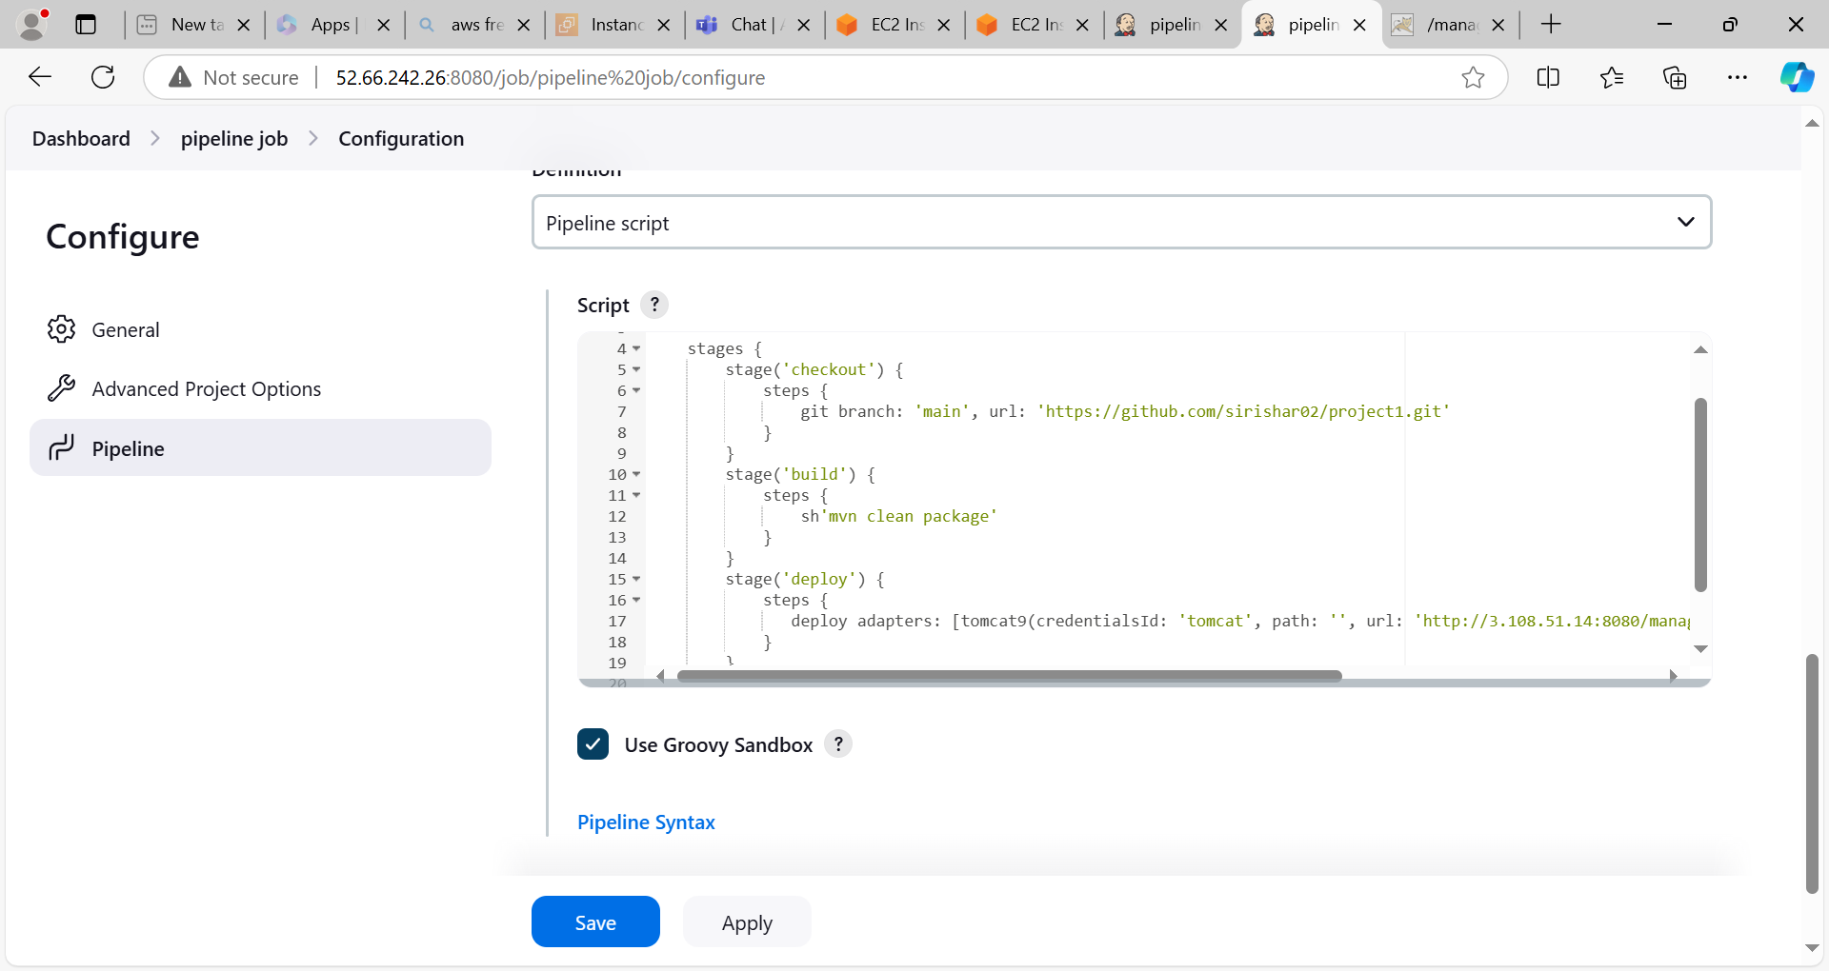

* Click on apply and save option.
* Click on **build now** option on Jenkins dashboard.
* Build is success

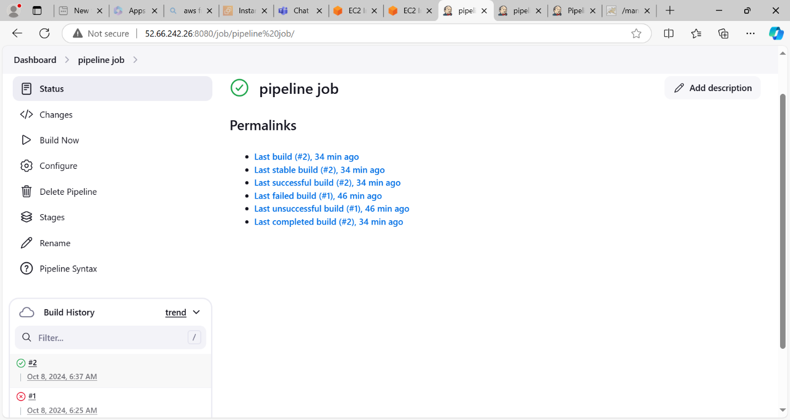

Console output

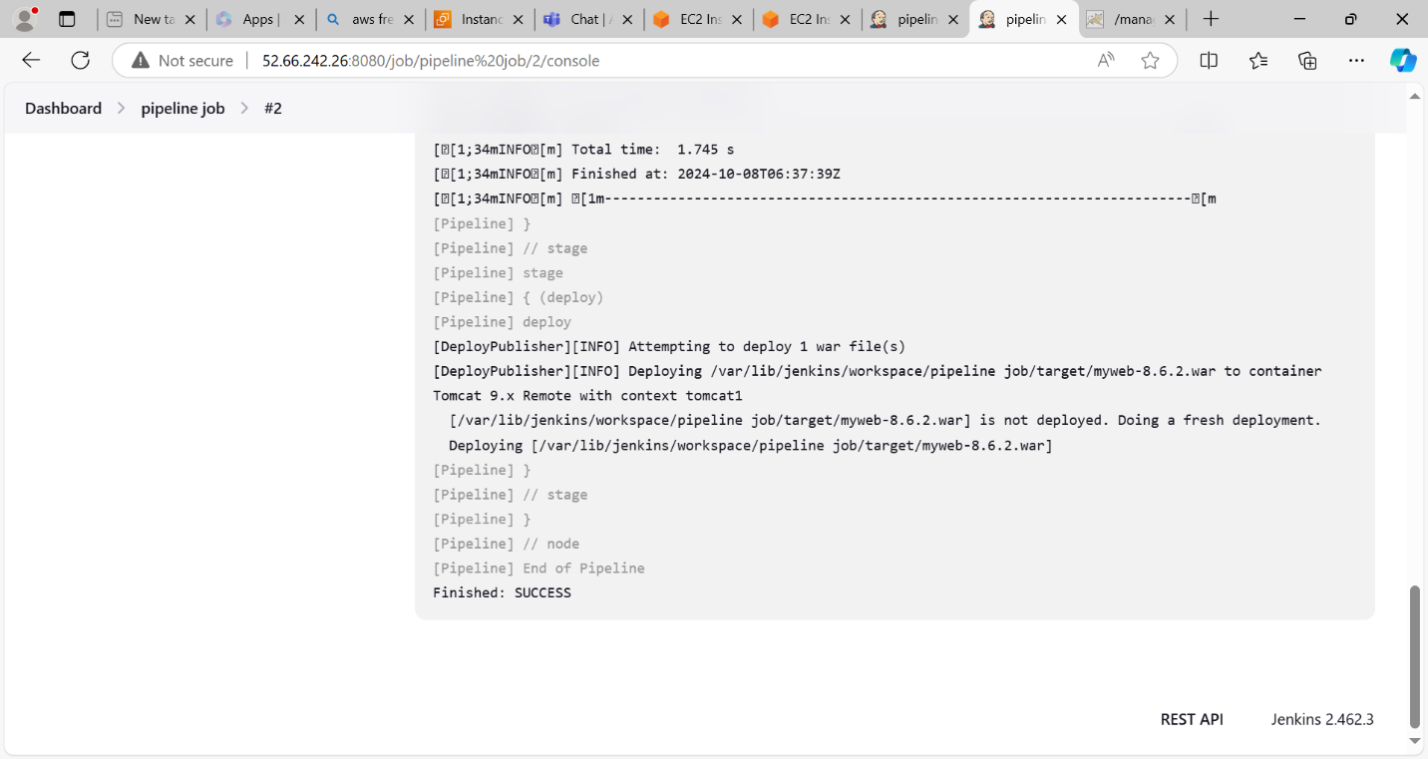

Deployed an application on tomcat successfully

